GOVERNMENT DEGREE COLLEGE-TEKKALI

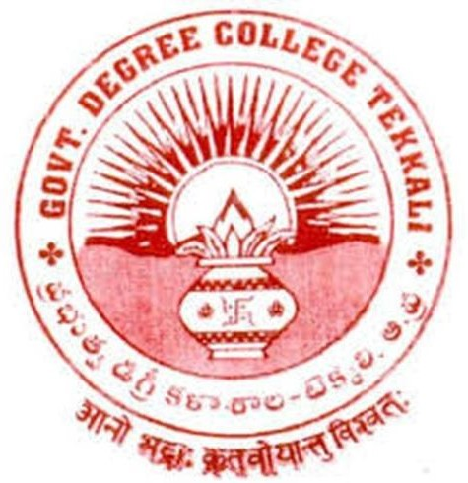

(Affiliated to Dr.B.R.Ambedkar University,Etcherla,Srikakulam)

# DEPARTMENT OF CHEMISTRY INDUSTRIAL VISITS / FIELD TRIPS

**Objectives :** 1. To acquaint with various instrumentation such as chromatographic techniques,NMR,IR,UV-Visible spectrophotometer etc.

1. To impart training and allow the students to visit various departments such as process of manufacturing,safety,Quality control(QC) and Quality assurance etc.
2. To create interest among students towards placements in Pharma industries.

**Outcomes :** 1. Students underwent acquaintance with the instrumentation, process of manufacturing,safety,QA and QC etc.

2. Students got a complete information about how a drug is manufactured in a Pharma industry.

|  |  |  |  |  |  |
| --- | --- | --- | --- | --- | --- |
| S.No. | Date | Name of the industry visited | Number of students  attended | Name(s) of faculty attended | Remarks |
| 1. | 05-03-2018 | Aurobindo Pharma ltd; Pydibhimavaram, Srikakulam District | **31** | D.Adinarayana T.Chandra Sekhar B.Parvathi |  |
| 2. | 22-02-2020 | Aurobindo Pharma ltd; Pydibhimavaram, Srikakulam District | **16** | D.Adinarayana M.Bala Krishna P.V.Satyanarayana T.Chandra sekhar  Ch.Sunitha |  |

# SUPPORTING DOCUMENTS

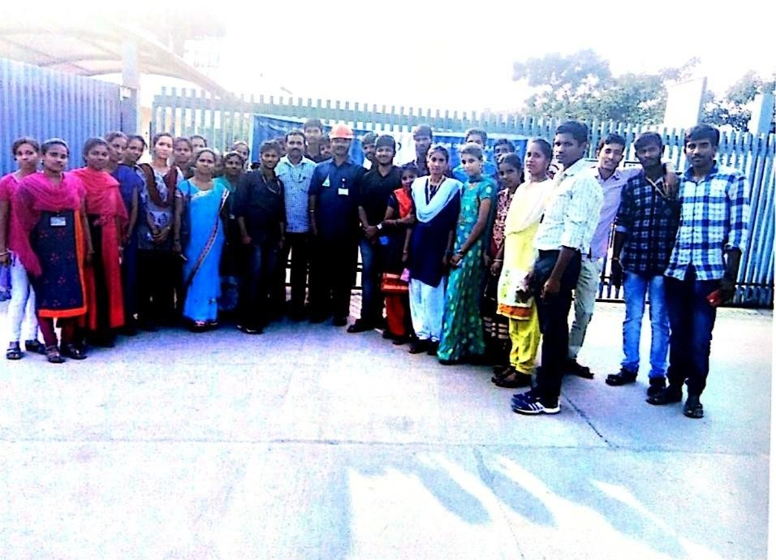

**Visited Aurobindo Pharma ltd; on 05-03-2018**

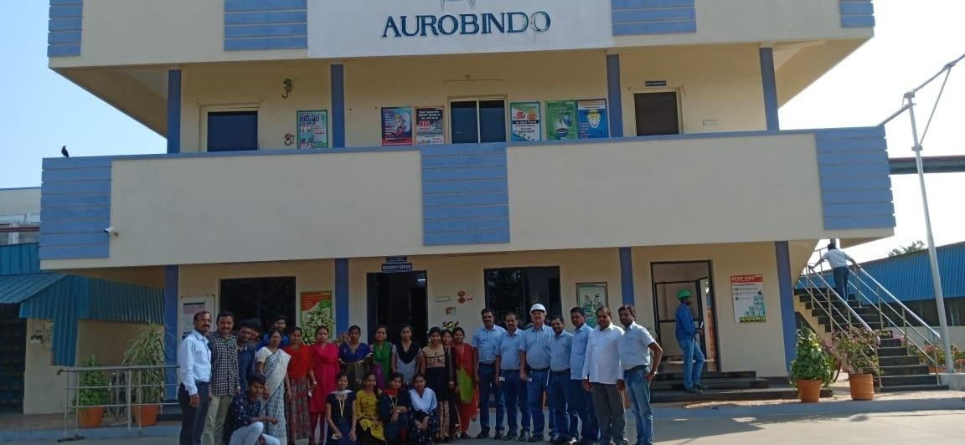

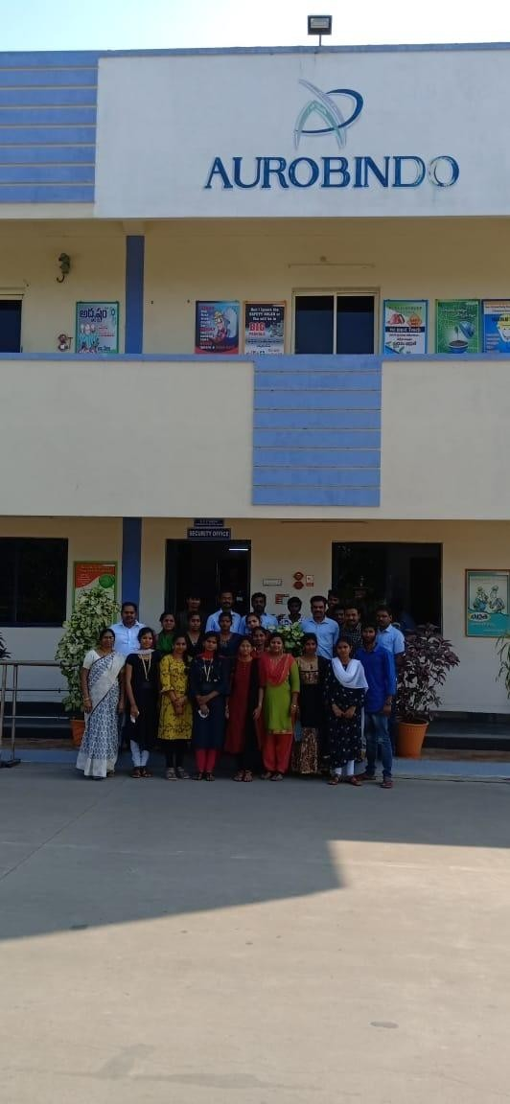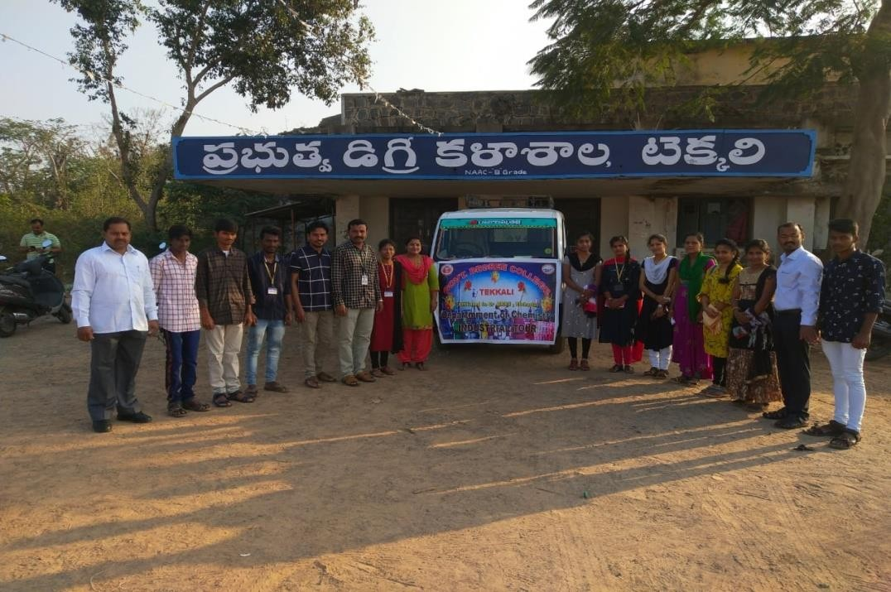**Visited Aurobindo Pharma ltd. on 22-02-2020**

